# Tracking the Balloon

This is perhaps the most essential part of the project: without a working tracker, you don’t get the balloon back when it lands. It is also the most complicated part of the project, the part most likely to go wrong and the hardest component to test (apart from the balloon itself).

## Preliminary Research

The [UKHAS website](https://ukhas.org.uk) has a wealth of information about everything to do with High Altitude ballooning. The most common method for tracking High Altitude balloons is APRS, which connects to the internet to allow you, and others, to view the flight in real-time. This method has both advantages and disadvantages. The main advantage is that anyone can track the balloon and upload the received data. This can greatly improve your chances of recovering the payload as the location can be sent to any receiver across the UK and you will be able to view it. However, this method can be very expensive, with receivers ranging from £100-£500. For obvious reasons, this is well out of our budget.

So, having dismissed APRS tracking, we had to look elsewhere.

We soon found a project by Dave Akerman called Pi in the Sky, which could be received with a SDR attached to a laptop, coupled with an antenna. Being quite experienced with the Raspberry Pi, this was a plausible option. However, it was still expensive (the PITS Zero costing £240).

The question remained: Was there anything cheaper?

After hours of research across multiple sites, including Reddit and GitHub, we came across LoRa, a radio protocol designed for the IoT. It stands for Long Range and it’s a low-power network protocol designed by Semtech. In the UK it uses the 433mhz and 863mhz frequencies. The 433mhz band is also used by APRS and Pi in the Sky tracking methods.

After further research, we discovered a number of projects that used LoRa for tracking, with seemingly good results.

Firstly, the LoRa record for the longest range was set using a HAB and the Things Network (a network of Internet-connected LoRa receivers) was set at 702.676km, which was great news when it came to the range of LoRa. If everything goes well, we will only need approximately 50km.

Secondly, a project by Stuart Robinson called LoRaTracker. He uses a cheap LoRa module made by Dorji, coupled with a Arduino Pro Mini 3.3V and Ublox GPS module to track balloons, and has written an extensive library for his boards. Best of all, the barebones tracker cost only £20 to build.

This looked to be the best option (mainly because of the cost!), but also because of some of the great results people seemed to be getting with this equipment.

## Building the Tracker

Once we had confirmed that this would work, we ordered the kit, which consisted of two PCB’s, two LoRa modules and the resistors, diodes and fuses, which totaled £20. In addition, we also had to order a GPS module (Ublox M8, £20), two FRAMs (£7), which allow the trackers to store information about the last known location, and two Arduino Pro Mini 3.3v.

Building the boards took about 4 hours, and consisted of soldering each individual resistor, fuse and diode to the main PCB, then connecting all the pins on the LoRa module, Arduino and GPS to the PCB, checking each component to ensure it was fully connected and finally, uploading test programs to ensure everything worked correctly over a USB to TTL adapter.

While uploading the Arduino Sketches to the Arduino Pro Minis, we had a problem: the board wasn’t responding to the Arduino Ide, and we got an error every time. After scouring Stack Overflow, we realized our mistake. The USB to TTL adapter didn’t have a reset pin, and was therefore unable to put the Arduino into download mode. More hours of searching resulted in us using the PCB of and Arduino Uno as a bridge to connect the Arduino Pro Mini to the computer. We were then able to upload the sketches successfully, and they worked.

## Testing the Trackers

Next came the most important stage of Tracking the Balloon: benchmarking the range of the trackers.

Our first tests were disappointing and we were only able to get a range of about 200m using a simple wire antenna. 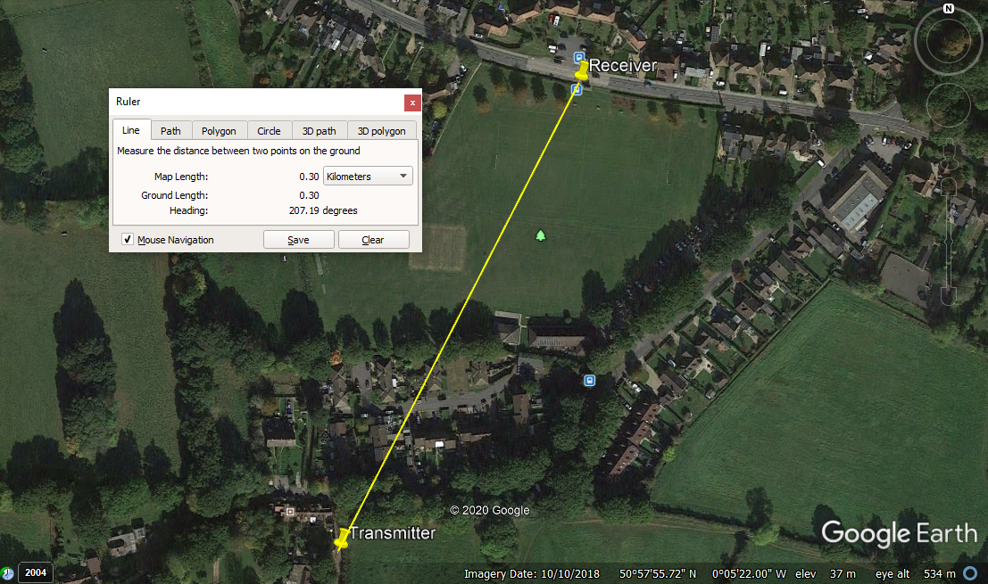

Disappointed, we returned home to try to work out why it wasn’t working. We found nothing specific to our case, but had ideas that the wire antennas probably weren’t functioning as intended.

Unable to find anything more online, we emailed Stuart Robinson, who designed the boards we use, asking what he uses. He responded, telling us that he uses the Diamond X-70N, a dual band 144/433mhz antenna. We decided to opt for the cheaper Diamond X-50N for the Receiver and a cheap 433mhz antenna from eBay for the Transmitter. We also had to get two IPX mounts for the PCBs and a SMA to IPX adapter to connect the antennas.

After everything arrived, we quickly soldered the mounts to the PCBs, connected the antennas and powered everything up.

Yet again, we were disappointed, having reached only 700m.

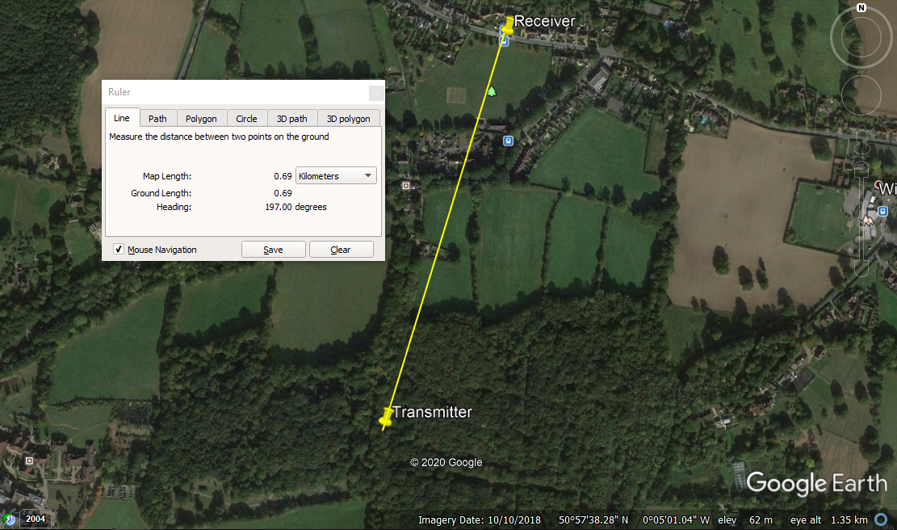Again, we returned home to research what had gone wrong. It was then that we were reminded of Line of Sight: you will get much further if you don’t have anything in between the Transmitter and Receiver. Our results were characteristic of the conditions we were testing in.

On to the next test. Next, we decided to test the Line of Sight range of the tracker. The obvious solution was right next to us: The South Downs. At roughly 200m, they are visible for miles from the flat countryside around them. With the Receiver up on Ditchling Beacon and the Transmitter on Ditchling Common, we were able to reach a distance of 5km, with a quick, reliable connection.

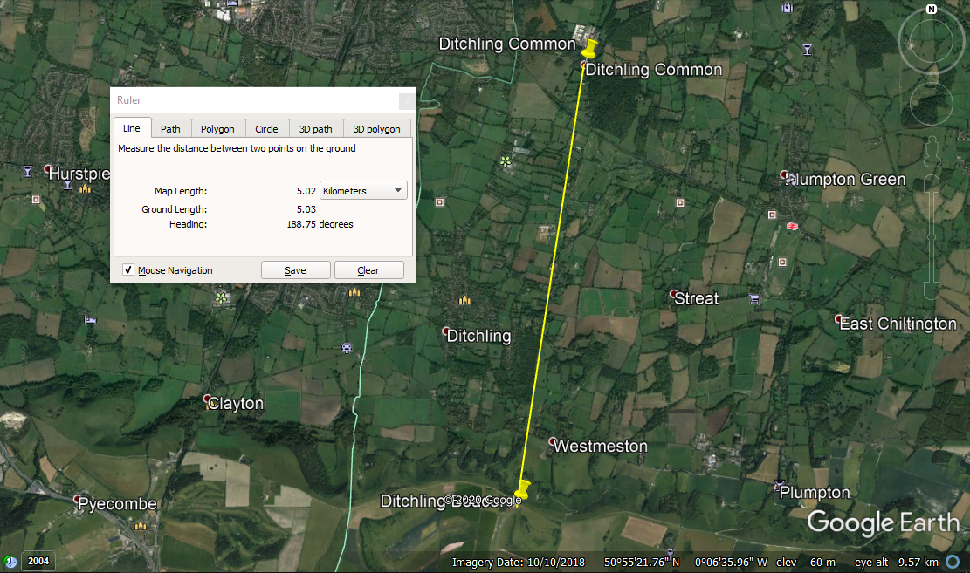

After having our first success, we quickly set our sights higher and decided to get a real benchmark on the tracker. Again, our location is ideal, as we decided to test from the North Downs to the South Downs, a distance of approximately 45km. We were successful: the connection was stable, and only faltered when the transmitter was lowered behind a hill. This shouldn’t be a problem when we launch, as the balloon will have a direct line of sight until it reaches about 200-300m above the ground and, by that time, it won’t travel far.

After hours of research and afternoons of testing, we finally established that out trackers were up to the job of tracking the balloon, and at a fraction of the cost of other methods.